 | E-Ink Display Instructions

Date: | 5/7/2022 | Version: | 1.1 | By: | Matt Little

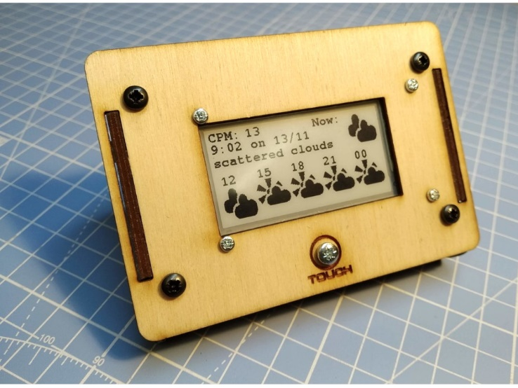 | Need a portable, low-energy, wireless display for the data you are collecting?  This display unit has an ESP32 Wi-Fi enabled microcontroller and a 2.13” e-ink display.  This kit is a simple, no-solder unit to get you up and running quickly.  It is designed for people who have some programming knowledge, as you will need to re-program the unit and make it do what you want.  These instructions cover the Standard version of this kit.
The kit is based on the TTGO T5 V2.3 2.13 Inch E-Paper Screen. This is available here:
http://www.lilygo.cn/products.aspx
And a github repository for their info and notes is here:
https://github.com/Xinyuan-LilyGO/T5-Ink-Screen-Series

We loved this little board and started to make it display the data we wanted. Examples we have built included:
- Weather display for your location
- Display data from Adafruit IO. In our case we display the radiation level in the workshop. Always useful!
- Quotation machine – need a boost? Touch the unit for an inspiring quote.
The limit is your imagination!
It displays the information even when the unit has gone to sleep, so is great for showing data or information that does not change too regularly.
You can set the unit to wake up on a touch, or to use the timer to wake it up at set intervals.
The kit includes a relatively simple wooden enclosure to hold everything and keep it at a nice display angle. We wanted something that would look nice on a mantelpiece!
It uses an 18650 lithium-ion cell, which is recharged via the micro USB connection. We have found a full battery to last for several hundred updates, but this does depend on your code.

The github repository for example code and the enclosure and these instruction files is available here:
https://github.com/re-innovation/TTGO_EPaper

Parts included:
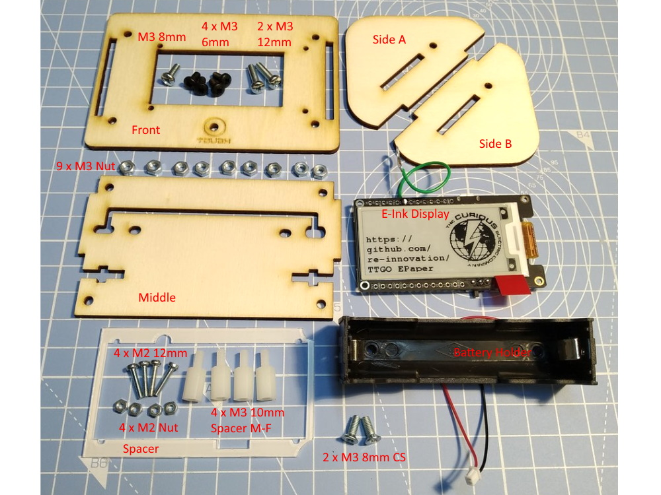

Parts list:
Item | Quant | Item | Quant
TTGO ESP32 2.13” E-Ink Display Unit | 1 | Enclosure Front 3mm laser cut wood | 1
Battery holder for 18650 cell with connector | 1 | Enclosure Middle 3mm laser cut wood
M3 8mm long counter sunk screw | 2 | Enclosure Side A 3mm laser cut wood
M3 6mm long pan head screw | 4 | Enclosure Side B 3mm laser cut wood
M3 8mm long pan head screw | 1 | Enclosure Spacer 1mm laser cut plastic
M3 12mm pan head screw | 2 | M3 10mm plastic hex spacers Male-female | 4
M3 Nut | 9 | M2 12mm screw | 4
 |  | M2 nut | 4
Note: You will also require an 18650 single Lithium Polymer battery cell. This is NOT supplied, due to shipping restrictions.

Tools required:
This is a no-soldering required kit. You will need:
- Small pozi screwdriver
- Flat nosed pliers

Build Instructions:
Step: 1 | Install battery holder
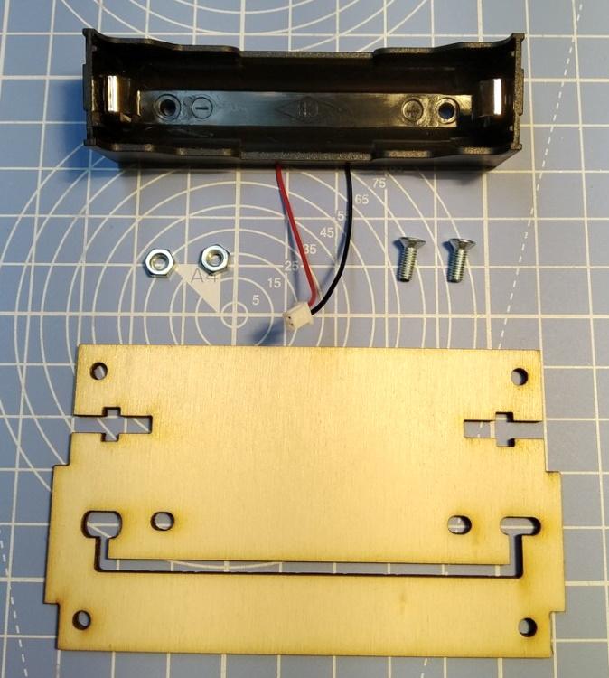  1:  2 x M3 8mm  Countersunk Screws  2 x M3 Nuts  Middle section  2:  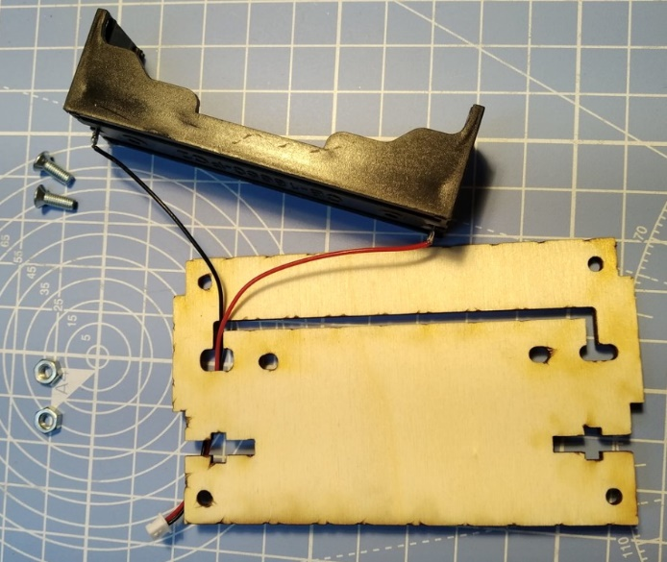  Fit connector  Trough the slot.  Align wires to two holes at end of slot |  | 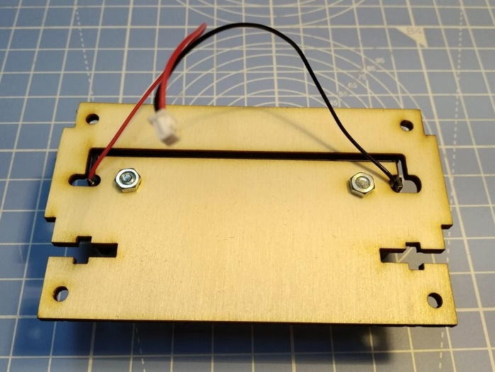  3:  Fit screws through battery holder and align with two holes.  Add nuts.  Note: The holes in the battery holder are just 3mm, so the screws might need turning to get them through the plastic holder.  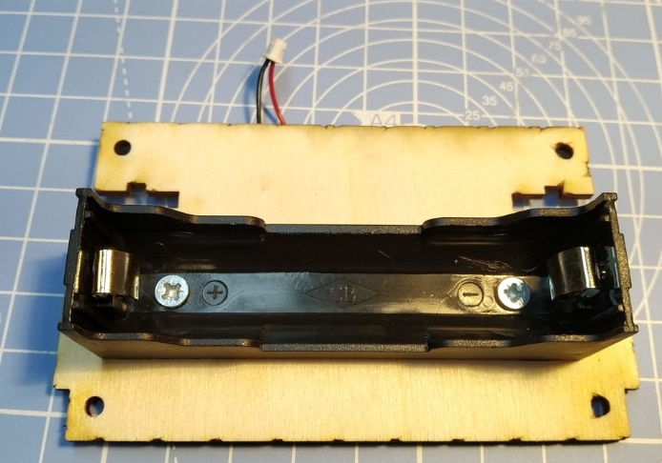  4:  Check all aligned and tighten.

Step: 2 | Add Spacers
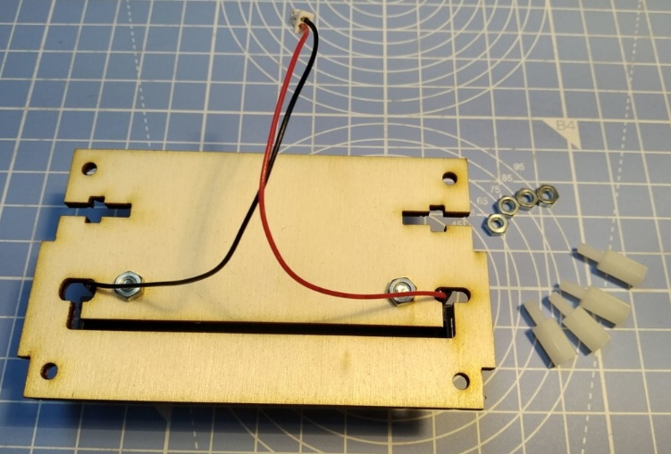  1:  4 x Hex Spacers  4 x M3 Nuts  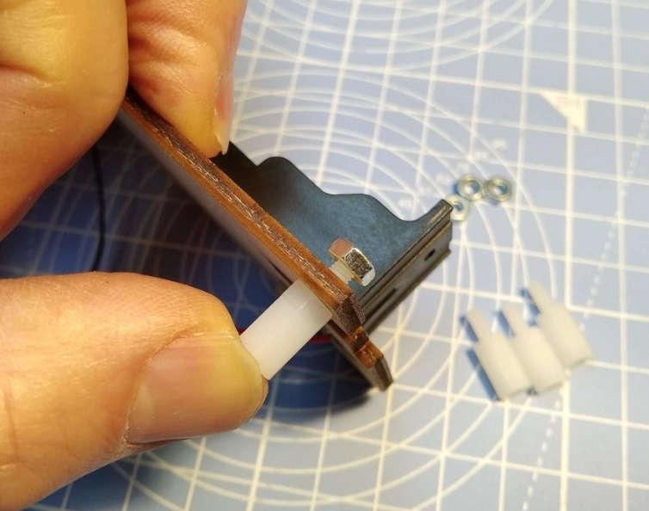  2:  Fit male end through 4 holes in middle section.  Add nuts. |  | 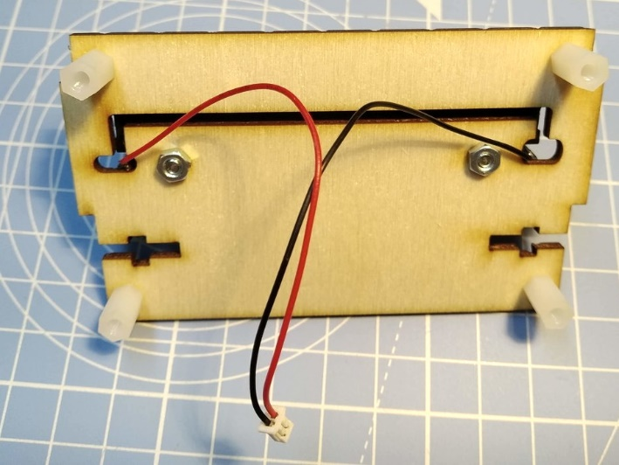  3:  This is what it should look like!

Step: 3 | Install E-Ink Display Board
E-Ink Board  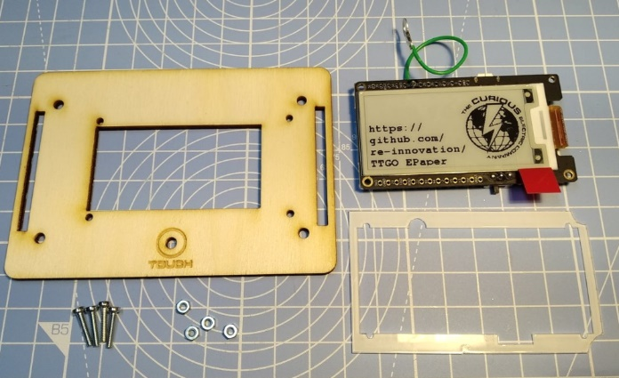  Spacer  Front  4 x M2 Nuts  4 x M2 Screws  Note: You should remove Protector from E-Ink and Spacer here. (I’ve not done this in these photos!)  Cut-outs  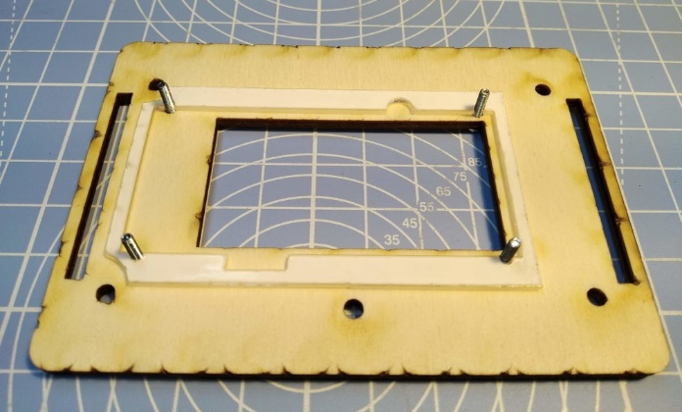  2:  Fit 4 x M2 screws through small holes.  Add Spacer on top.  Ensure cut outs are as shown. |  | 1:  3:  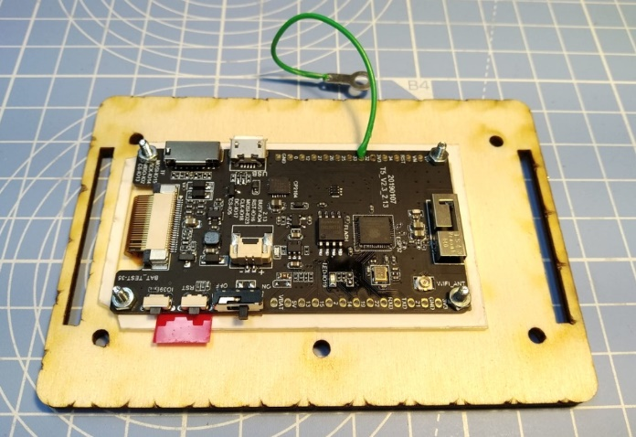  Align E-Ink board to four M2 screws.  Check orientation of display (touch hole should be at the bottom).  Add M2 nuts and tighten.

Step: 4 | Add Touch Pad
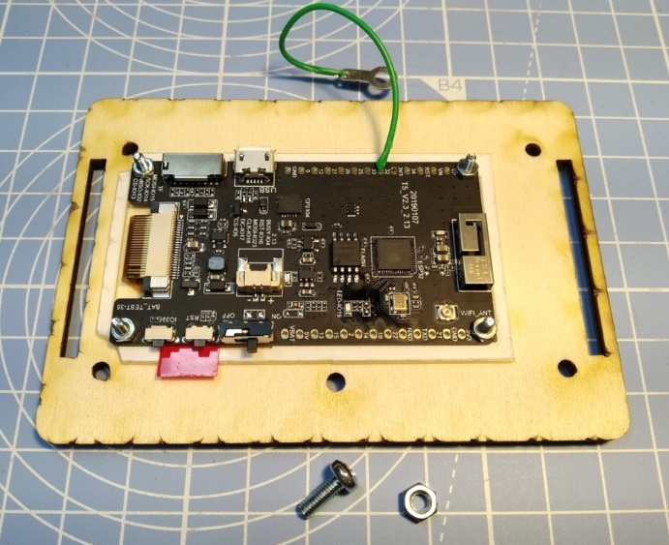  1:  M3 8mm Screw + Nut  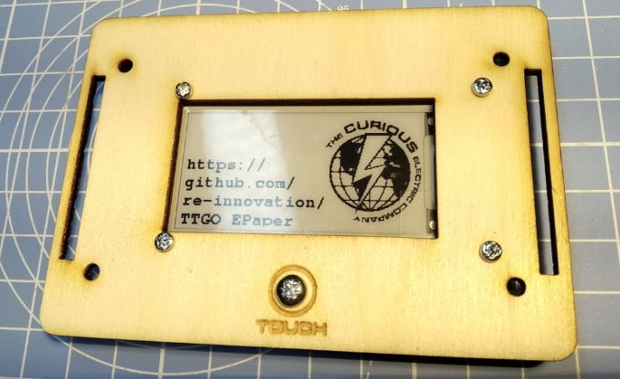  This is what it should look like!  3: |  | 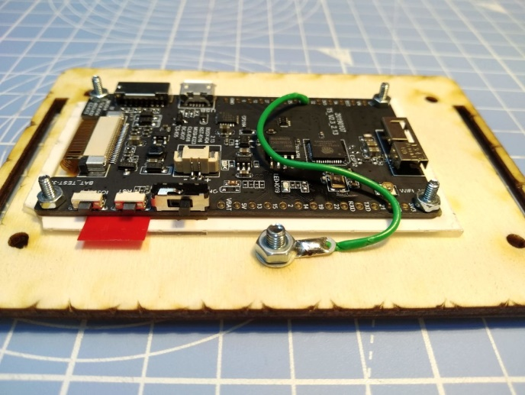  2:  With head of screw on front of display, hold touch sensor solder pad, add Nut and tighten.  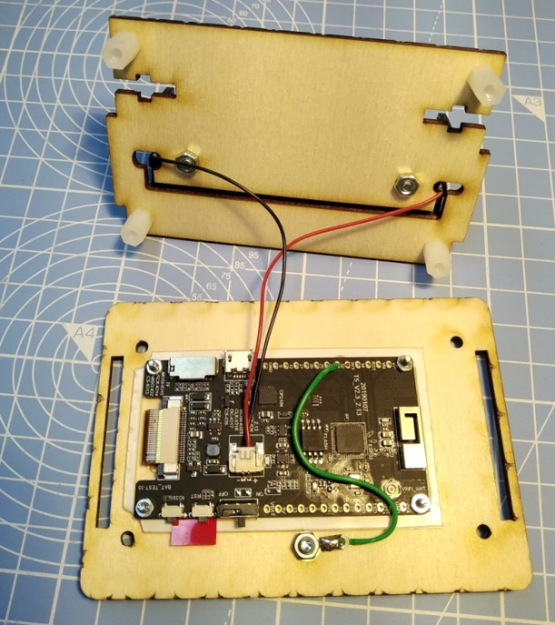  4:  Plug in battery connector to PCB

Step: 5 | Add Sides
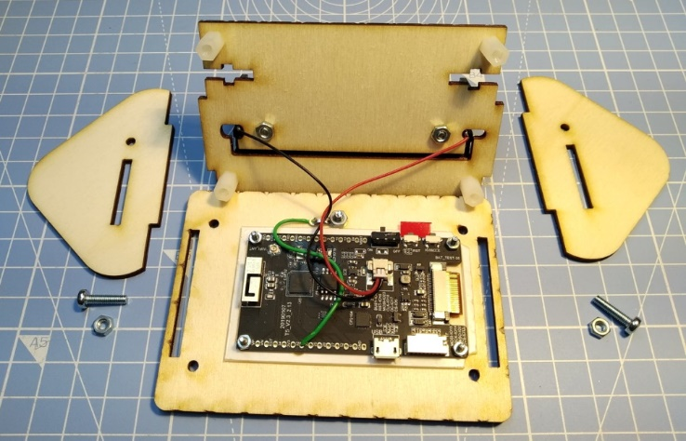  1:  Side A  Side B  M3 12mm Screw +Nut  M3 12mm Screw +Nut  2:  Ensure ‘good’ face (with less laser cut marking) of the wood is showing out.  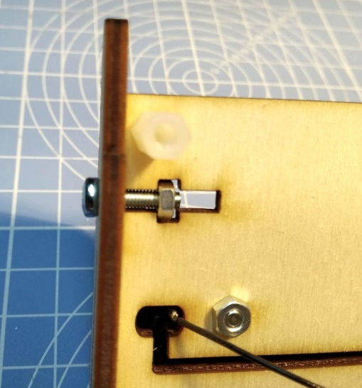  Hold Nut in place.  Put screw through.  Tighten slightly.  This can be a bit fiddly!  Do this for both sides. |  | 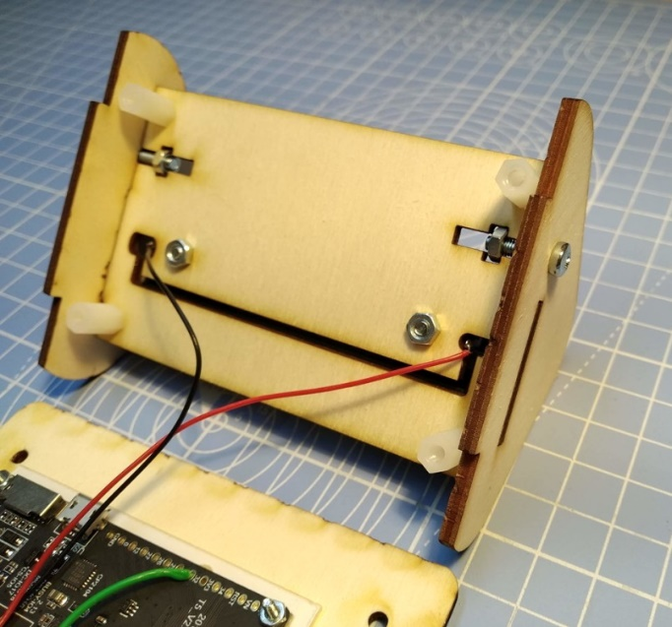  3:  This is what it should look like!

Step: 6 | Add Front
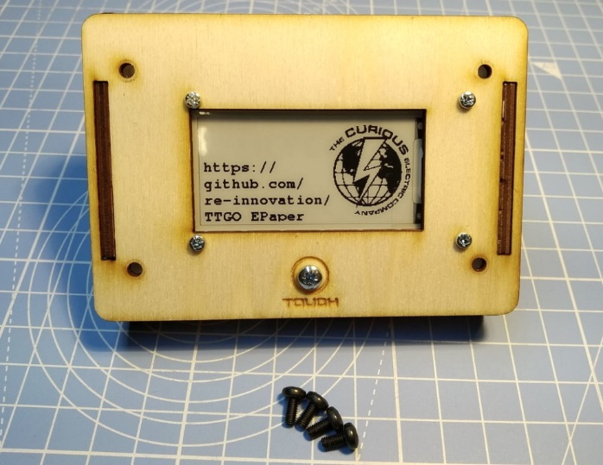  1: |  | Align the front display section to the two slots. Ensure the display is the correct orientation.  Use the 4 x M3 6mm screws through the four holes in the front to fit into the plastic hex spacers and hold the unit all together.  You may need to tighten the side screw here to hold it all together.

Step: 7 | Unit Build Finished!
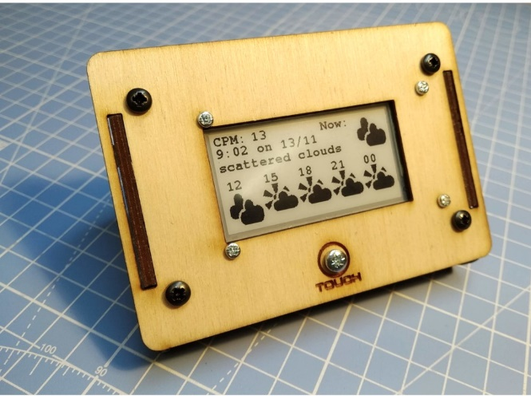  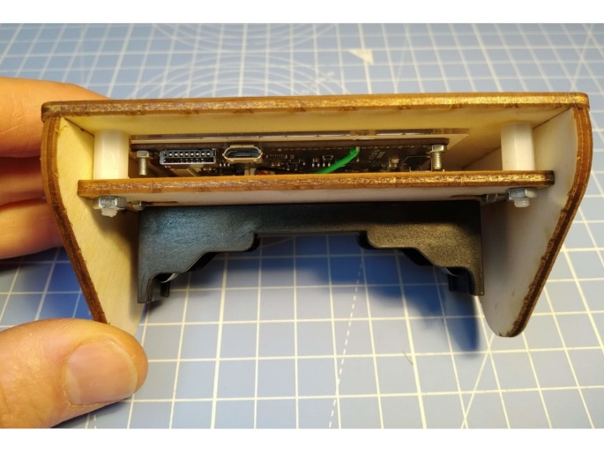  USB Charge/programming socket  Micro SD Socket  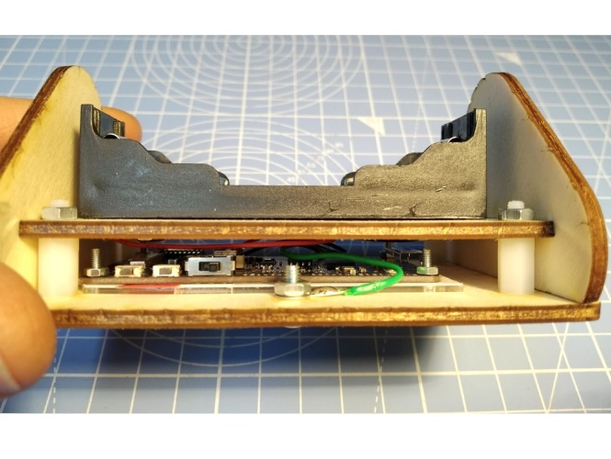  IO39 Reset On/Off |  | 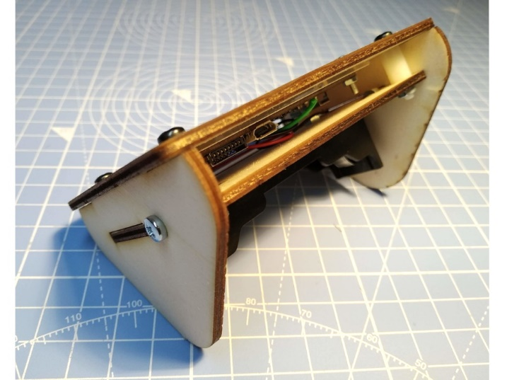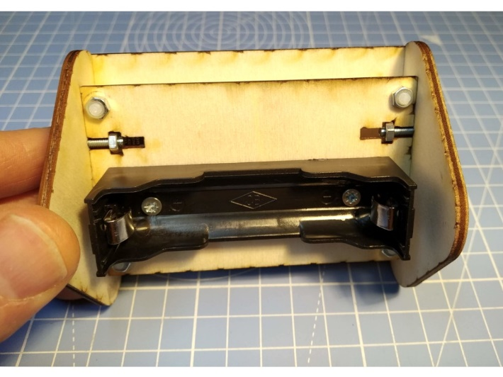  Add 18650 Lithium Polymer Cell here  Note: Ensure correct orientation of battery.  Pressing button “IO39” will put the unit into Access Point mode for updating configuration parameters or changing WiFi SSID and password.

Step: 8 | Programming Notes
Sample code and information regarding programming your unit is available on the github repository here:
https://github.com/re-innovation/TTGO_EPaper

This repository also contains all the design files for the enclosure and these instructions.

Contact Details:
We would like you to be happy with this kit. If you are not happy for any reason, then please contact us and we will help to sort it out.
Please email hello@curiouselectric.co.uk with any questions or comments.
Please tweet us at @curiouselectric
If any parts are missing from your kit then please email hello@curiouselectric.co.uk with details and, if possible, where the kit was purchased.
More technical information can be found via www.curiouselectric.co.uk

This kit has been designed and produced by:
The Curious Electric Company
hello@curiouselectric.co.uk
www.curiouselectric.co.uk

